McCallum - George Balanchine
Historical & Cultural Context

Overview & Context
WHO are the learners?
Age range: 14-15
Skill level: Beginner-Advanced beginner
Demographic (cultural background, SES, special abilities):
WHAT, WHERE, WHEN – Context:
Type or Genre of class: dance history/creative
Location / Situation: McCallum high school
Learning Trajectory: close to end of school year
Length of the class; pacing for time available: 80 minutes
WHY Teaching Philosophy:
WHAT - Content & Scope:
Overarching Goal(s): Students will know George Balanchine’s contribution to dance history and the characteristics of his style as seen in Who Cares?
Concept/Theme/Focus: George Balanchine: influence of broadway/hollywood on American ballet
Vocabulary:
WHAT - Equipment and Materials (include bibliography of references):
- Music: I got rhythm by Gershwin
- One-sheet Balanchine info handouts (x ~ 50)
- Laban Movement Efforts Poster
- Movement Sentence Poster
- Large paper for group brainstorm
- Markers
- Video recording of Who Cares?
Stage 1: Identify Desired Results - WHAT
See National Core Arts Standards in Dance for examples
Enduring Understanding  George Balanchine made a significant contribution to dance history.  Choreographers are inspired by those who came before them. | Essential Question  What is George Balanchine’s contribution to dance History?  How can you create work inspired from Balanchine?

Student Learning Standards :
TEKS  - Identify historical figures in dance history and their significance.  - Create basic compositional forms using fundamental dance elements for choreographic processes.  - Choreograph short dance phrases that exhibit an understanding of various historical periods and social contexts.  - Incorporate appropriate movement vocabulary when identifying qualities and discussing meaning of performance or production in dance.  - Demonstrate appropriate audience behavior and etiquette in the classroom and at performances.  - Demonstrate kinesthetic and spatial awareness individually and in groups. | NCAS-Dance  - B. Experiment with the elements of dance to explore personal movement preferences and strengths, and select movements that challenge skills and build on strengths in an original dance study or dance. DA:Cr1.1.HSI  - A. Collaborate to design a dance using choreographic devices and dance structures to support an artistic intent. Explain how the dance structures clarify the artistic intent. DA:Cr2.1.HSI  - A. Embody technical dance skills (for example, functional alignment, coordination, balance, core support, clarity of movement, weight shifts, flexibility/range of motion) to retain and execute dance choreography. DA:Pr5.1.HSI  - C. Connect energy and dynamics to movements by applying them in and through all parts of the body. Develop total body awareness so that movement phrases demonstrate variances of energy and dynamics.DA:Pr4.1.HSI  - a.Analyze dance works and provide examples of recurring patterns of movement and their relationships that create structure and meaning in dance. DA:Re7.1.HSII  - a.Analyze the artistic expression of a dance. Discuss insights using evaluative criteria and dance terminology. DA:Re9.1.HSI  - a.Analyze a dance to determine the ideas expressed by the choreographer. Explain how the perspectives expressed by the choreographer may impact one’s own interpretation. Provide evidence to support one’s analysis. DA:Cn10.1.HSI
Student Learning Outcomes: Determine 2-4 specific learning outcomes for the lesson.

- Students will be able to identify dance elements within Balanchine’s Who Cares?
- Students will be able to create movement inspired from Balanchine.
- Students will be able to embody and perform their own interpretations of Balanchine’s style.
- Students will be able to analyze and articulate movement elements and artistic intent when watching peers.
Stage 2: Determine evidence of learning

HOW - Assessment: Include when, what, who
During analyze, critique, compose teachers will walk around observing students ability to identify and embody movement elements they see.

During introduction:
- ask students what their previous knowledge of Balanchine/ musicals are, and identify qualities
After viewing film:
- ask students to identify themes/moods of the clip, ask what made them think that
- ask groups to work together to identify specific movement elements
Explore/Embody:
- ask them how they are using the movement elements they picked out to create movement
- observe how students are engaging with each other and the elements
Compose/refine:
- walk around to groups ask to show what they have
- ask how they can improve/ explore with something more
- make sure each group is on task, everyone participating, they have all the guidelines of the dance recipe
show/perform it:
-ask students to identify movement elements they see, what they appreciated and why
Stage 3: Plan learning experience & instruction Creative Class
7Es: Creative or Historical Class – general guidelines
See accompanying document for explanations and guidelines: Lesson Planning Process_Template_Annotated

Elicit/The Hook/Introduction: 5-10 min
Who has ever seen a Broadway or a Hollywood musical? What do you think of when you think of old, classic musicals? Or Who? Maybe Fred Astaire, Ginger Rogers, Gene Kelly? Leave time for them to answer questions.
Has anyone ever heard of George Balanchine? What do you know about him? Tell me anything that comes to mind. What about NYCB? Mr. Balanchine is actually known as the father of American Ballet, but before that and NYCB was established he worked in hollywood and broadway, choreographing for musicals and commercial work. He was an immigrant from Russia and he was a struggling artist, he had to find a way to make money before he could do anything else and he discovered that he loved American musicals and jazz and hollywood and city life. His favorite dancer was actually Fred Astaire.
(pass out one-sheets)
Here are some fun facts about Mr. Balanchine and today we are going to talk a little more about his significance in dance history and look closer at his ballet Who Cares
(go around the class asking each to read one fact from the sheet)
Ask for volunteers
Name of Exercise: View it 5 min
Objective/focus: Students will watch historical work to understand Balanchine’s style
Script: Now we are going to take a look at a ballet he created in 1970 called “Who Cares?”. So Mr. Balanchine created dance from what he saw all around him and from his experiences. This ballet is all about love! Who cares explores four different types of love, passionate love, old/family love, young/exciting love, and friendly love. This is also about his love for New York City life, which hopefully you will see in this excerpt. We don’t have time to watch the whole thing today, but let’s look at a little excerpt from the finale.
- Watch for: 1) overall mood/ descriptive words,
2) to enjoy, think about how it makes you feel
- Ask WHY did you think that (encourage inquiry)
What are the overall themes/qualities/mood you saw in this clip? Write down on white board/ big paper while volunteers share. What made you think that?
Also ask: what makes this different from ballet you usually see? Why?

Name of Exercise: Analyze/Critique it 15 min
Objective/focus: Students will identify movement elements that stand out in Who Cares?
Script: Now we are going to separate you into groups, we’ll watch the video a few more times, and look for more specific things. Count off 1-4 going around the room. Show where in the rooms each group will be placed, if need be, count down from 5 to be in their designated places. Pass out handouts with the dance elements, large paper, and markers. Now this time when we watch it, look for specific dance elements in your groups category. (1.effort dynamics, 2.use of space, 3. relationships, 4.body/action) Clarify that they can include dance elements not listed on the poster but within the same category.
- Watch 2-3 more times, give students 5-10 minutes to write, assign one person to be scribe
- Go around to groups making suggestions/asking questions
- 5 minutes each group shares what they wrote: Can I have 2 volunteers from group 1 stand up and share what you wrote. (write 2-3 main elements on white board/big paper)

Name of Exercise: Embody/Explore it 10 minutes
Objective/focus: Students will interpret movements they observed and explore them within their own bodies
Accompaniment: In the mood – Glenn Miller, Herman’s Habit – Justin Hurwitz
Script: Now that we have written down some more specifics about Balanchine’s unique style, let’s try to embody it for ourselves. Let’s take the next 10-15 minutes exploring the various elements you wrote down, and coming up with your own moves in the style of Balanchine. Stand up, spread out, take a moment to find your space and get into your own bodies. Put music on. Go around reminding them of specific actions/qualities/use of space to help them explore. Try doing your movement with a partner. How would you move if you are(insert mood words). Bring them back by giving 3 min and 1 min warnings.

Name of Exercise: Compose It 15 min
Objective/ focus of exercise: Students will embody elements of George Balanchine’s Who Cares? and create movement inspired from his work.
Accompaniment: I got Rhythm by Gershwin (playing softly)
Script: Return to your groups that you were just in when we analyzed the work and took notes on the papers. You are each going to number off and make new groups where there is one person from each area. You each will be the experts for your specific area in your new groups. When I point at you, say the next number and hold up that number with your hand. Start counting off with the students until they pick it up on their own. Can I have all the 1’s in this corner, 2’s in this corner….. As this happens, move to the corners of the room that you are referring to and hold up the number of the group with your hand.

You have ___ minutes to collaborate with your group members to create a movement phrase inspired from elements identified in Who Cares? Here is your movement recipe that you will use. Refer to a written/visual representation. Everyone begins in a still group shape in relationship with each other. You have 16 counts for movement, and then end in a different group shape in relationship with each other. Within your 16 counts of movement, include 2 of following: Unison, Duets, Repetition. You have ____ minutes. Go. Walk around the room to each group and ask them to show you certain parts of their dance. Give time cues.

I am going to turn on some music and all together, practice your movement phrase in your groups. This is just a rehearsal, but use this to see what happens when you perform your phrase with music. Find your beginning still shape. And begin…. Everybody should be finding their end shape. And relax.

Take 1 minute in your groups to go over anything that went wrong.

Name of Exercise: Show It 5 min
Objective/ focus of exercise: Students will perform in groups for their peers in the style of Balanchine.
Accompaniment: I Got Rhythm by Gershwin
Script: We are now going to perform for each other. Can I have a group that would like to volunteer to perform first? Choose a group that seems like they know what they are doing. If you are not performing, come sit at the front of the room. Everyone is watching this group perform. Performing group is finding their beginning shape. Turn on music. Begin when you are ready. Place each groups big paper with movement elements in front of audience, so they know how to respond after.
Repeat above for each of the groups.
After each group has performed, ask audience to identify what they appreciated and why, 2-3 people.

Name of Exercise: Refine It 5 min
Objective/Focus of exercise: With their understanding of where Balanchine got his inspiration for works, students will apply their knowledge of their own community to their movement phrase.
Accompaniment:
Script: As we learned earlier, Balanchine pulled inspiration from the world around him. Through his works we can see how his love for American and New York played a part in Balanchine’s choreography. Being here in Austin, we have a pretty unique city. As choreographers, we could allow the world around us to impact our work, just as Balanchine did. Remaining in your group, add 2 moves to the dance phrase you have already created, that are inspired from the Austin city/community. Return to the corner of the room I originally assigned you, and take ___ minutes to add your 2 Austin inspired movements. Go. Give time reminders as students work. Walk around to each group and ask them to perform certain their 2 movements for you.

Name of Exercise: Perform It 10 min
Objective/Focus of exercise: Students will perform their entire Balanchine inspired movement phrase.
Accompaniment:
Script: We are now going to perform our new movement phrases for each other. Can I have a group that would like to volunteer to go first. Choose group that looks like they know what they are doing. If your group is not performing, come sit at the front of the room. The performing group is finding their beginning still shape. And begin when you are ready.
Repeat above for all groups.

*If time allows, after each group, have the audience members identify the elements of the group’s dance that are representative of Balanchine’s style. Have them also identify the Austin inspired movements.

End of class reflection: Ask students to gather around in a circle. “What are you taking away from today?” “What is something new you learned?” “How did you problem solve in your groups?” “Did you ever surprise yourself?”
George Balanchine
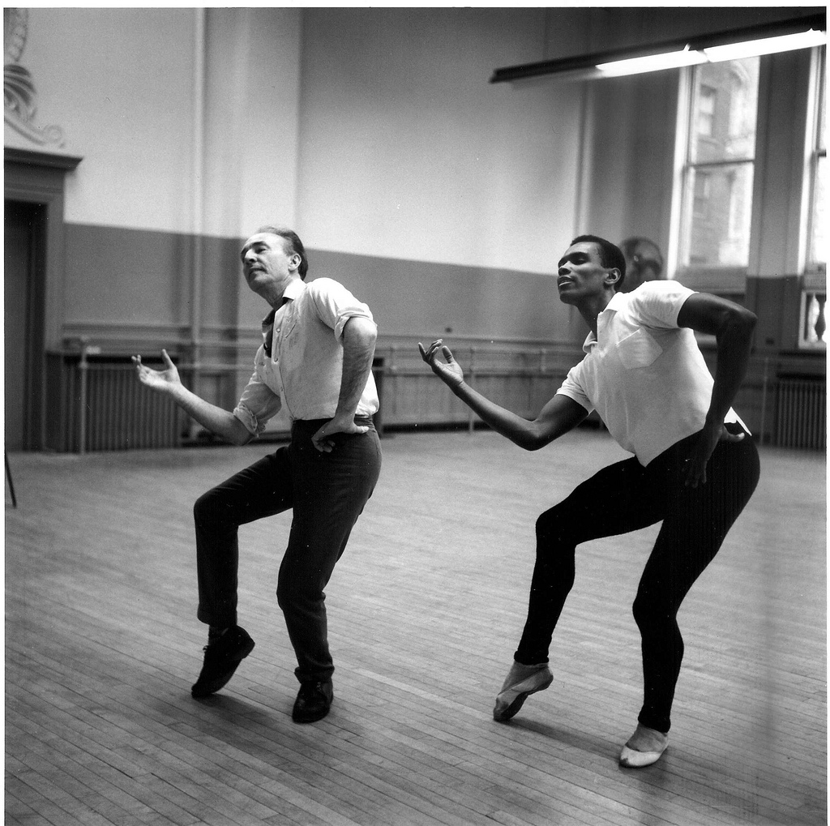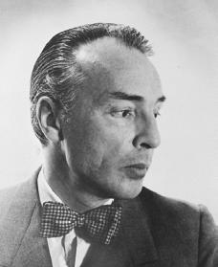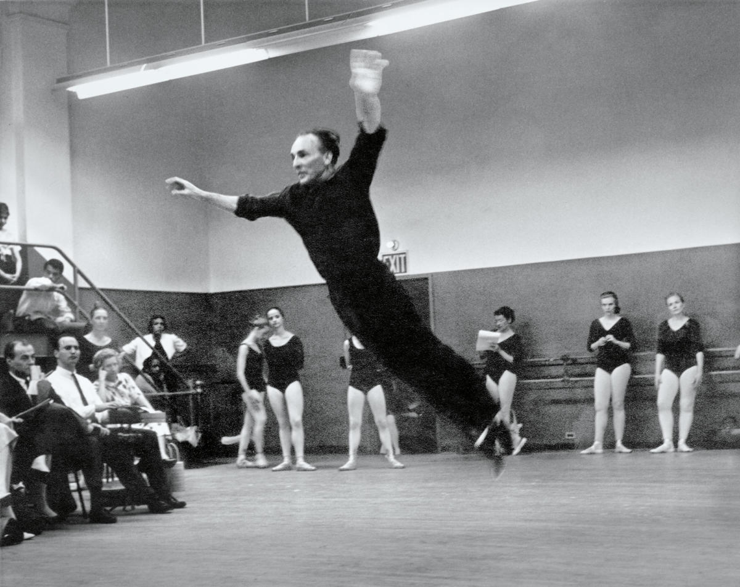
- George Balanchine was born in St. Petersburg, Russia in 1904. He began dancing at age 10 with the Maryinsky Theatre Ballet Company, then joined the Ballet Russes in Paris in 1924.
- Balanchine eventually became ballet master there, and committed to full-time choreography. He choreographed for companies and projects all over Europe.
- He moved to the United States in 1933, and co-founded the American School of Ballet in 1934 where he would choreograph his first ballet in the U.S., Serenade.
- He also choreographed for musical theatre and the Hollywood film industry. He choreographed Broadway’s On Your Toes in 1936.
- In 1948 the New York City Ballet was born and Balanchine had found a permanent home/career until his death in 1983.

- He choreographed 465 works in his lifetime, such as Firebird, The Seven Deadly Sins, Stars and Stripes, Who Cares?, and A Midsummer Night’s Dream.
- His movement is characterized by speed, risk taking, rhythm, and influences of broadway jazz and Africanist aesthetics. His favorite dancer was Fred Astaire.

- Balanchine loved America! He combined his European classical ballet expertise with his love of modern American city-life, contemporary movement, and musical theatre to create what we know as American ballet.

- In his ballet Who Cares?, dancers portray different types of love. Balanchine also illustrates his love for America and the exuberance of New York life.
- Who Cares?: costumes by Barbara Karinska, 16 songs, music by George Gershwin made in 1930’s, 40 min long, premiered in 1970

https://www.nycballet.com/ballets/w/who-cares.aspx
http://balanchine.com/who-cares/
http://dancetabs.com/2012/04/new-york-city-ballet-all-american-bill-washington/

